**How a Tankless Water Heater Works**

Think about it: The way most households in this country heat water is absurdly wasteful. We fill up big 40- to 50-gallon storage tanks, then pour energy into them 24/7, year in and year out, to make sure we have hot water at the ready whenever we want it. But often it doesn’t work out that way. If a teenager takes a long shower, or a spouse settles in for a tub soak, there can be a long wait for that emptied tank to reheat. Then there are the nagging worries: Is it filled with energy-robbing sediment? Will it spring a leak? Both are reasonable concerns, as tanks generally fail in 8 to 12 years.

These are the arguments for investing in a tankless water heater. It generates hot water only when you need it—and for as long as you need it—saving 27 to 50 percent of fuel costs over tank-type heaters. (A typical gas-fired tank wastes 40 to 50 percent of the fuel it burns.) And because there’s no tank to fail, there’s almost no chance of a catastrophic leak. What’s more, since their introduction in the United States in the 1990s, tankless heaters have become increasingly sophisticated, with features like built-in recirculating pumps (for “instant” hot water), and wireless connectivity that tells you via smartphone exactly when a unit needs maintenance.

Below is our guide to tankless water heaters. In it, we’ll explain how a tankless water heater works, tell you what you need to know before you buy one—and before the installer arrives—and let you in on the units’ operating quirks, so there won’t be any surprises if you go tankless.

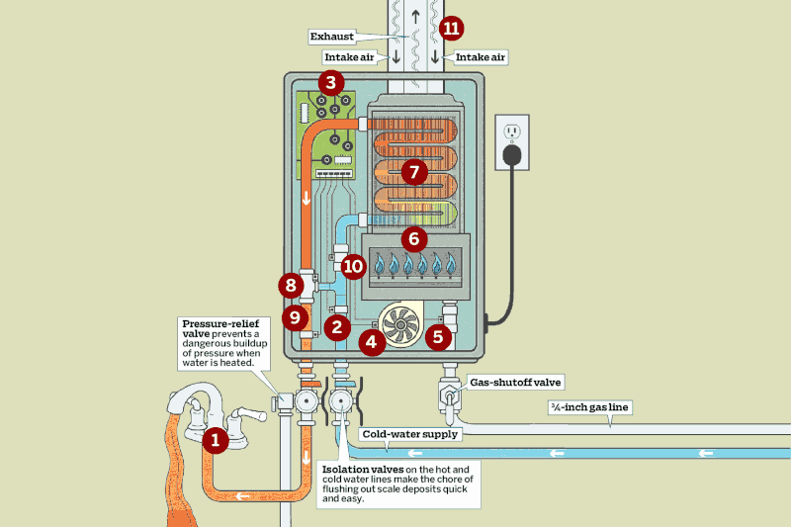

1. It all starts when you turn on the **hot-water tap (1)**.
2. A **flow sensor (2)** detects water coming into the heater and sends a signal to the control panel to start producing hot water.
3. In a gas-fired unit, the **control panel (3)** turns on the **fan (4)**, which draws in outside air, opens the **gas valve (5)** that lets in the gas, and ignites the **burner (6)**.
4. The **heat exchanger (7)** captures heat from the flames and transfers it to the water moving through the exchanger’s tubing.
5. The **mixing valve (8)** tempers the superheated water exiting the exchanger.
6. If the **temperature sensor (9)** detects that the water exceeds or falls short of the desired setting, the panel will adjust the gas valve, the mixing valve, and the flow-regulating **water valve (10)** accordingly.
7. A sealed **vent (11)** (or pair of vents) through a roof or outside wall carries away exhaust gases and conveys combustion air to the burner.

FROM: https://www.thisoldhouse.com/plumbing/21019184/read-this-before-you-buy-a-tankless-water-heater